BY APPOINTMENT ONLY
CUSTOM MOUTH GUARD FITTING SCHEDULE 2017
For RICHMOND HILL HOCKEY ASSOCIATION

Presented by Puck-Err Up Custom Athletic mouth guards
Lynne Sillars-Thomson, Registered Dental Hygienist

*These dates by appointment, set up your delivery date at the appointment*
Weekend appointments can be same day delivery
EMAIL LYNNE to book puckerrupmouthguards@rogers.com

(clinics subject to cancellation if bookings are insufficient, be sure to book an appt.)
September
Sunday | Monday | Tuesday | Wednesday | Thursday | Friday | Saturday
 | 4  Labour Day | 5 | 6 | 7 | 8  TG arena  6-8:30 | 9  TG arena  9-2
10  TG arena  9-12 | 11 | 12 | 13 | 14 | 15  TG arena  6-8:30 | 16  TG arena  9-2
17  TG Arena  9-12 | 18 | 19 | 20 | 21 | 22 | 23
24 | 25 | 26 | 27 | 28 | 29 | Elgin 30  Barrow  9-1:00

Servicing and sponsoring Richmond Hill Minor Hockey since 2004
$45.00
(payment can be made by
cash or check to Puck-Err Up Mouth Guards
at these specified organization clinics )
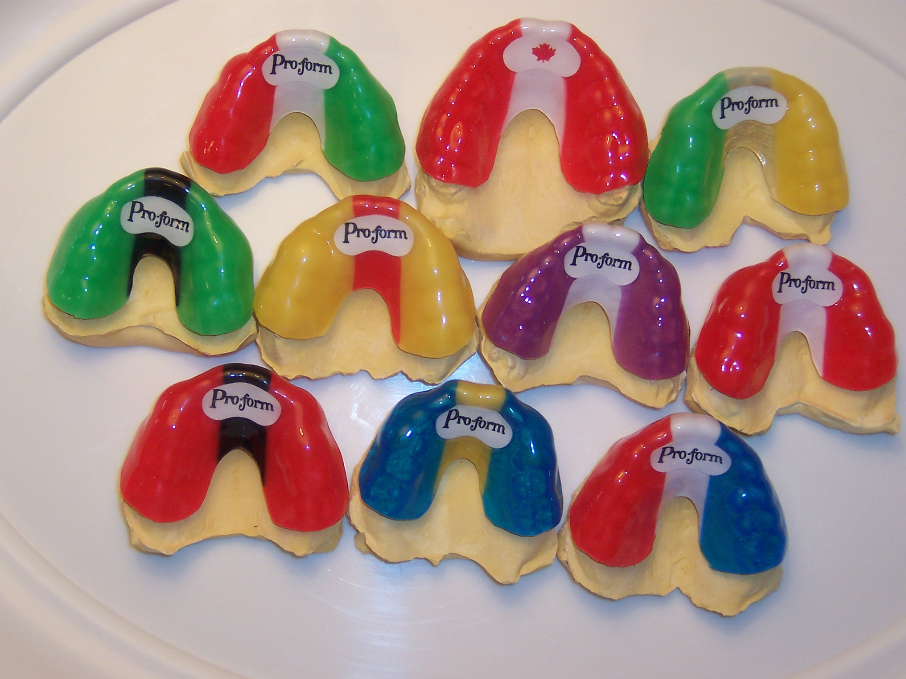
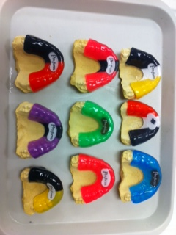
OTHER COLOURS ARE AVAILABLE

BREATH EASIER, SPEAK EASIER, HYDRATE EASIER
with a custom mouth guard

